**Dynamic cloud computing architecture for cloud-assisted internet of things in the era of Big data, IoT and AI**

**What is cloud computing:**

Cloud computing is a general term for anything that involves delivering hosted services over the internet such as server, security, storage, speed etc.

**Cloud Computing Architecture**

As we know, cloud computing technology is used by both small and large organizations to store the information in cloud and access it from anywhere at anytime using the internet connection.

Cloud computing architecture is a combination of service-orientedarchitecture and event-driven architecture.

Cloud computing architecture is divided into the following two parts -

* Front End
* Back End

Diagram-

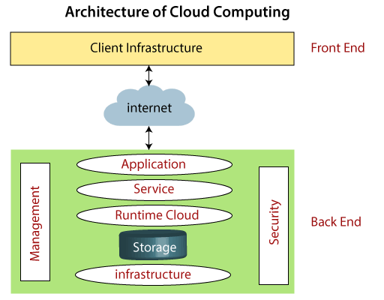

**Types of cloud computing services-**

**Infrastructure as a service (IaaS)**saves you money on buying physical data centers or servers.when we pay we go and only pay for as long as you need or use the service. IaaS allows you to adjust your scale depending on your demand quickly.

**Platform as a service (PaaS)**has everything you need for business applications. It comes complete with infrastructures such as networking, online storage, and servers, as well as database management systems, development tools, and more. PaaS is designed to help create, test, develop, and update your application.

**Software as a service (SaaS)**is what you get whenever you download a new app for your phone. Companies create and develop their software and then lend it out to buyers. Businesses such as Autodesk, Lending Club, Microsoft, and IBM all generate revenue from SaaS .example-Netflix

**Problem**

# What are the Security Risks of Cloud Computing-

# Data loss- Data loss is the process in which data is being deleted, corrupted, and unreadable by a user, software, or application. In a cloud computing environment, data loss occurs when our sensitive data is somebody else's hands, one or more data elements can not be utilized by the data owner, hard disk is not working properly, and software is not updated.

1. Data Breach- is the process in which the confidential data is viewed, accessed, or stolen by the third party without any authorization, so organization's data is hacked by the hackers.
2. Vendor lock-in -Vendor lock-in is the of the biggest security risks in cloud computing. Organizations may face problems when transferring their services from one vendor to another. As different vendors provide different platforms, that can cause difficulty moving one cloud to another.